**Clients’ satisfaction is the priority while achieving fast delivery.**

I launched and operated an online fashion store in Yahoo Bid between 2011 and 2016. Our delivery promise was to ship in 5 days, which came along with many challenges, including staff shortage, departure of business partners, unstable supplies, meeting customers’ expectations, as well as negotiating with Yahoo Bid. In the end, we fulfilled our goal and earned the trust of our customers. The feedback and reviews were 99.02% positive!

**Failure is often expected in the startup and entrepreneur sector.**

In the first few months of starting the company, the sales were very slow and the revenue was close to zero dollar, but we were still optimistic. I received many cynical and negative comments like, “You can’t make it!” “Why can’t you take a regular job?” “Stop dreaming!” and “This is simply impossible!” All these negative and discouraging comments hurt my feelings. However, I chose not to be defeated by criticism and frustration. Because I had done my homework about the market and trends, I proceeded with confidence that my business model would work.

**There is only one chance!**

Just as our online sales accelerated, I rejoiced exceedingly in receiving an e-mail from Yahoo Bid. I was invited by the marketing department of Yahoo Bid Taiwan to attend a meeting at Yahoo’s Headquarters. I arrived at the Headquarters only to find out that I was one of the more than three hundred sellers arranged to meet with Yahoo’s Marketing Manager. As I was lined up to be the last person to meet the manager, I had to wait for the appointment for the whole day, from morning to dusk. I even missed my nightshift of online sales because of the waiting. The ten-hour waiting ended on a conversation of a couple of minutes before I was sent away. The manager just told me: “The Christmas promotion is in two months. Please send me your proposal by e-mail.”

My promotion proposal was a jacket for US$3.99. I defeated over three hundred sellers and was granted the top page on Yahoo Bid.

**The cross-promotion with Yahoo Bid was unexpectedly successful.**

Most customers wanted to order our jackets. The sales number went up by 1250% compared with the same month of the previous year. This was the 2nd year of my business. The rapid growth was so unexpected that it caused problems to maintain the balance of shipments and payments, and negotiate with suppliers. Eventually, I optimized the process of procurement, shipping, and payment by **using data analysis to** **document every delivery and payment cycle, weather impact, festivity period, and customer feedback.** While my competitors usually shipped in 7-14 days, my company could ship in 5 days. The optimal data analysis also helped increase our cashflow.

**Tears in eyes and on the face, unable to tell if it was sweat or tears.**

Tina was a shipping staff, who burst into tears at two o’clock in the morning. The tears flowed down her face like a river escaping a dam. I had to comfort her. It was November, one month before the Christmas season, and not to mention the cold weather also helped with winter clothing sales. To keep our shipping promise, we had been busy packaging from eight o’clock in the morning. It was two o’clock at the midnight and the shipment was not done. We were all so exhausted and I must add staff to meet shipping deadlines. Finally, it was decided to add five shipping personnel to catch up with the four-month Christmas peak season shipments.

Way before Christmas in November, we were overloaded with orders, which was almost drowning us. There was no pathway in the warehouse. Wherever I moved, I felt like swimming in a pool, a pool not filled with water, but with goods that customers ordered.

Wedding is once in a lifetime event. To meet a client’s need, I bought a ticket to Guangzhou, China, and the goods was delivered to the customer in time.

Many of my customers were repeat customers. I believe repeat customers are the most valuable kind. Therefore, no matter how difficult their requests are, I will try my best to meet the challenges and solve problems for them. This was how the story went. Ann was a repeat customer. She specially ordered a dress to attend her best friend’s wedding. As the dress was out of stock, I bought a ticket to fly to China to procure the dress and mailed it to Ann. Ann eventually wore the beautiful dress to attend her friend’s wedding in time.

**Every order contains details to attend to**

I hope every customer receiving his/her ordered package from us, like opening a Christmas gift, feels so cheerful with joy, and happy all day long. I value every customer’s needs and will take extra effort to satisfy his/her needs. We respect our customers and treat their needs as a mission to achieve.

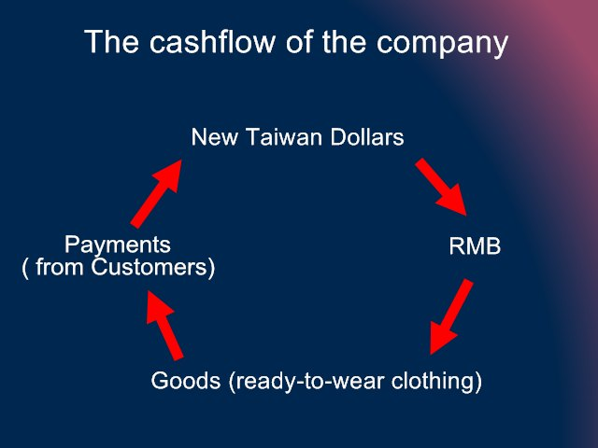

The cashflow of the company

New Taiwan Dollars -> RMB -> Goods (ready-to-wear clothing) -> Payments from Customers -> New Taiwan Dollars

The logistics of the company

Garment Manufacturers in China -> Ready-to-Wear Clothing Wholesalers -> Logistics in China -> Export to Taiwan (via sea or airfreight) -> Company Warehouse -> Logistics in Taiwan -> Shipment to Customer

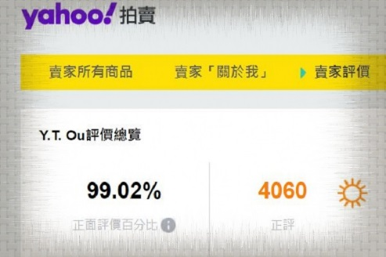

My former e-commerce online clothing store in Yahoo: 99.02% positive from customers reviews

https://tw.bid.yahoo.com/rating/Y2326595916/listing